

**COLLEGE OF ENGINEERING**

**DEPARTMENT OF COMPUTER ENGINEERING**

A Predictive Maintenance Software for Managing Classrooms in Kwame Nkrumah

University of Science and Technology

BY

Momoreoluwa Monsuru-Oke

Noah Jamal Nabila

Mawuli Acorlor

Supervisor: Eliel Keelson

March 2025

# Declaration

We hereby declare that this project work is an original work done under the supervision of Dr.

Eliel Keelson of the Computer Engineering department of Kwame Nkrumah University of Science and Technology

Signature…………………………… Date ……………………………………

Monsuru-Oke, Momoreoluwa Atanda (Candidate)

Signature…………………………… Date……………………………………...

Nabila, Noah Jamal (Candidate)

Signature…………………………… Date……………………………………...

Acorlor, Mawuli (Candidate)

Signature…………………………… Date……………………………………...

Dr. Eliel Keelson (Supervisor)

# Abstract

The maintenance of infrastructure, equipment, and facilities at the Kwame Nkrumah University of Science and Technology (KNUST) currently follows a reactive approach, where repairs are conducted only after equipment failure or breakdown. This results in unexpected downtime of critical systems, higher maintenance costs, shortened equipment lifespan, and disruptions to academic activities and staff productivity. To address these challenges, this project proposes the design and implementation of a predictive maintenance system that leverages data analytics and machine learning to anticipate equipment failures before they occur.

The system will consist of a data collection module to monitor key equipment parameters, a predictive analytics engine to analyse the collected data and predict potential failures, and a userfriendly dashboard for maintenance staff to visualize equipment health and receive alerts. Additionally, the system will include a scheduling module to optimize maintenance activities based on predicted failures and resource availability, as well as a reporting module to track maintenance history and provide insights for future planning.

The proposed system aims to reduce downtime, lower maintenance costs, extend equipment lifespan, and improve overall operational efficiency at KNUST. By transforming the current reactive maintenance approach into a proactive one, the system will enhance the learning environment for students and improve staff productivity.

This project contributes to the growing body of research on predictive maintenance by providing a tailored solution for university facilities, with a focus on data collection, analysis, and userfriendly interfaces. The successful implementation of this system at KNUST will serve as a model for other institutions seeking to improve their maintenance practices and achieve sustainable facility management.

# DEDICATION

We dedicate this project to our families, whose unwavering support, patience, and encouragement sustained us through the challenges of this journey. Your sacrifices and belief in our potential made this achievement possible. The faculty and staff of KNUST, whose guidance and commitment to excellence inspired us to push boundaries in engineering and innovation. Future students of Computer Engineering, with the hope that this work contributes to a legacy of proactive solutions for sustainable education in Ghana and beyond. ”To those who light the path so others may walk farther.”

# ACKNOWLEDGEMENT

We gratefully acknowledge the support that made this project possible, our supervisor, Dr. Eliel Keelson, for his expert guidance and patience throughout this project. We also want to say a big thank you to the Department of Computer Engineering at KNUST for providing the academic foundation and resources for our work. To our families for their unwavering support and encouragement during this challenging process. To our peers and colleagues for their valuable feedback. To the KNUST maintenance staff who contributed practical insights This achievement stands on the shoulders of all who supported us along the way. Thank you

Table of Contents

Declaration 2

Abstract 3

DEDICATION 4

ACKNOWLEDGEMENT 5

List of Abbreviations 8

List of Figures 9

List of tables 10

Chapter 1: Introduction 11

1.1 Background 11

1.2 Problem Statement 11

1.3 Project Objectives 12

1.4 Significance of the Study 12

1.4.1 Significance of the Study (SDGs) 13

1.5 Organization of the Report 14

Chapter 2: Literature Review 15

2.0 Introduction: Overview of Predictive Maintenance 15

2.1 Maintenance 15

2.1.1 Reactive Maintenance 16

2.1.2 Preventive Maintenance 16

2.1.3 Predictive Maintenance 17

2.2 Machine Learning 18

2.2.1 Machine Learning Types 19

2.3 Related Works 19

1. Automation of Predictive Maintenance Using Internet of Things (IoT) Technology at University-Based O&M Project 19

2. Hybrid Intelligent Predictive Maintenance Model for Multiclass Fault Classification 20

3. Design and Control of High Thermal Mass Radiant Systems By Carlos Duarte Roa UC Berkeley HVAC Systems (2020) 23

4. Makerere University's PdM Pilot (2021) – Nalubega & Kavishe 24

5. NTU Singapore (2022) Acoustic-Based Early Fault Detection in Classroom Projectors Using Deep Learning, Tan et al 25

2.4 Challenges in Predictive Maintenance 26

2.5 Conclusion 28

Chapter 3: Methodology 29

3.1 Introduction 29

3.2 Software Process Model 29

3.2 Justification for Waterfall 30

3.3 Tools & Technologies 30

References 31

# List of Abbreviations

Articifial Neural Network

ANN .................................................................................................................................... 20, 22

Artificial Intelligence

AI ................................................................................................................................... 18, 20, 31

Corrective Maintenance

CM ....................................................................................................................................... 19, 20

Cuckoo Search Algorithm

CSA ..................................................................................................................................... 21, 22

Heating, Ventilation, and Air Conditioning

HVAC ...................................................................................................................... 23, 24, 31, 32 high thermal mass radiant

HTMR ....................................................................................................................................... 23

integrates Improved Complete Ensemble Empirical Mode Decomposition with Adaptive Noise

ICEEMDAN .............................................................................................................................. 20

Internet of Things

IoT ....................................................................................................................................... 17, 19

Intrinsic Mode Functions

IMFs .......................................................................................................................................... 21

Kwame Nkrumah University of Science and Technology

KNUST...................................................................................................................................3, 11

Least Squares Support Vector Machine

LSSVM...................................................................................................................................... 20

Linear Discriminant Analysis

LDA ..................................................................................................................................... 20, 22

Machine Learning

ML ................................................................................................................................. 18, 21, 31

Nanyang Technological University

NTU ........................................................................................................................................... 25

Predictive Maintenance

PdM ......................................................................................................................... 17, 24, 25, 26

Preventive Maintenance

PM ....................................................................................................................................... 19, 20

Principal Component Analysis

PCA ..................................................................................................................................... 20, 27

Principla Component Analysis

PCA ................................................................................................................... 20, 21, 22, 23, 27

Support Vector Machine

SVM .................................................................................................................................... 20, 22

Sustainable Development Goals

SDGs ......................................................................................................................................... 13

# List of Figures

Figure 1: Advantages and disadvantages of reactive maintenance ............................................................. 14

Figure 2: Advantages and disadvantages of preventive maintenance ......................................................... 15

Figure 3: Advantages and disadvantages of predictive maintenance .......................................................... 16

# List of tables

Table 1: Overview of the development cycle of the Waterfall Model ........................................................ 28

# Chapter 1: Introduction

## 1.1 Background

The Kwame Nkrumah University of Science and Technology (KNUST) is one of the leading universities in Africa, known for its commitment to academic excellence and research. However, like many institutions, KNUST faces challenges in maintaining its infrastructure, equipment, and facilities. The current maintenance approach is reactive, meaning that repairs are conducted only after equipment failure or breakdown. This approach leads to unexpected downtime of critical systems, higher maintenance costs, shortened equipment lifespan, and disruptions to students' learning environments and staff productivity.

In recent years, the concept of predictive maintenance has gained traction as a solution to these challenges. Predictive maintenance leverages data analytics and machine learning to anticipate equipment failures before they occur, allowing for proactive maintenance scheduling and resource allocation. This approach not only reduces downtime and costs but also extends the lifespan of equipment and improves overall operational efficiency.

The importance of predictive maintenance is particularly evident in the context of university facilities, where the reliability of infrastructure directly impacts academic activities and research. By implementing a predictive maintenance system, KNUST can transform its maintenance approach from reactive to proactive, ensuring a more efficient and sustainable operation of its facilities.

## 1.2 Problem Statement

The current reactive maintenance approach at KNUST results in several inefficiencies, including unexpected downtime of critical systems, higher maintenance costs due to emergency repairs, and shortened equipment lifespan. Additionally, the lack of a systematic approach to maintenance leads to inefficient resource allocation, frequent emergency procurement cycles, and increased administrative burden.

A predictive maintenance system can address these issues by leveraging data analytics to anticipate equipment failures before they occur. This system would enable KNUST to optimize maintenance schedules, reduce downtime, and extend the lifespan of its equipment. Furthermore, it would provide a more efficient and sustainable approach to facility management, ultimately enhancing the learning environment for students and improving staff productivity.

## 1.3 Project Objectives

###### 1.3.1 General Objectives

1. Transform KNUST's reactive maintenance approach into a proactive predictive maintenance system
2. Reduce equipment downtime and extend asset lifespan across university facilities
3. Optimize resource allocation and maintenance scheduling
4. Improve overall maintenance efficiency and cost-effectiveness

###### 1.3.2 Specific Objectives

1. Develop a data collection system to monitor key equipment parameters across selected university facilities.
2. Design and implement algorithms that can analyse collected data to predict potential equipment failures.
3. Create a user-friendly dashboard for maintenance staff to visualize equipment health and receive alerts.
4. Build a scheduling system to optimize maintenance activities based on predicted failures and resource availability.
5. Implement a reporting system to track maintenance history and provide insights for future planning.
6. Develop a complaint reporting interface for users to report unexpected issues, with automated ticket generation.
7. Reduce procurement cycle frequency through better planning of parts and supplies.

## 1.4 Significance of the Study

The implementation of a predictive maintenance system at KNUST has several significant benefits:

1. **Reduced Downtime**: By anticipating equipment failures, the system will minimize unexpected downtime, ensuring that academic activities and research are not disrupted.
2. **Cost Savings**: The system will reduce emergency repair costs, optimize inventory management, and lower labour costs through better scheduling of maintenance staff.
3. **Extended Equipment Lifespan**: Proactive maintenance will extend the useful lifespan of university assets, reducing the frequency of equipment replacement.
4. **Improved User Experience**: Students, faculty, and staff will benefit from a more reliable infrastructure, leading to increased satisfaction and productivity.
5. **Data-Driven Decision Making**: The system will provide actionable insights for maintenance budget allocation and future facility planning.
6. **Sustainability Benefits**: By optimizing equipment performance, the system will reduce energy consumption and waste, contributing to a lower carbon footprint.

##### 1.4.1 Significance of the Study (SDGs)

This project advances two critical United Nations SDGs through its innovative maintenance framework:

SDG 4: Quality Education

By preventing avoidable equipment failures in classrooms, the system:

* Significantly reduces disruptions to teaching and learning activities
* Ensures reliable access to essential educational technologies
* Protects mandated instructional contact hours
* Creates more equitable learning experiences across campus facilities

SDG 12: Responsible Consumption and Production

Through data-driven resource management, the solution:

* Minimizes unnecessary procurement of spare parts
* Reduces waste generation from premature equipment replacements
* Optimizes usage of maintenance materials and consumables
* Promotes sustainable lifecycle management of educational assets

The project aligns with:

* SDG Target 4.1 (ensuring quality education) by maintaining optimal teaching environments
* SDG Target 12.5 (waste reduction) through intelligent inventory controls and predictive maintenance scheduling

This dual focus demonstrates how operational improvements in university maintenance systems can simultaneously support educational outcomes and environmental sustainability goals. The approach serves as a replicable model for other institutions seeking to align their infrastructure management with broader development agendas.

## 1.5 Organization of the Report

This report is organized into five chapters. Chapter 1 provides an introduction to the project, including the background, problem statement, objectives, and significance of the study. Chapter 2 reviews relevant literature and existing systems related to predictive maintenance. Chapter 3 outlines the methodology used in the design and implementation of the system. Chapter 4 presents the results of the system's testing and evaluation. Finally, Chapter 5 concludes the report with a summary of findings, challenges encountered, and recommendations for future work.

# Chapter 2: Literature Review

#### 2.0 Introduction: Overview of Predictive Maintenance

Predictive maintenance is a proactive approach to equipment maintenance that uses data analytics and machine learning to predict potential failures before they occur. Unlike reactive maintenance, which addresses issues after they arise, predictive maintenance aims to prevent failures by continuously monitoring equipment conditions and analysing trends.

Predictive maintenance has emerged as a critical component of modern facility management, particularly in large institutions like universities. This chapter reviews relevant literature and existing systems related to predictive maintenance, focusing on the technologies, methodologies, and challenges associated with its implementation. The review aims to provide a comprehensive understanding of the current state of predictive maintenance and identify gaps that this project seeks to address.

The key components of a predictive maintenance system include:

1. Data Collection and Storage: Historical equipment data (e.g., maintenance logs, failure records, operational parameters) is collected and stored for analysis.
2. Data Preprocessing: The data is cleaned, transformed, and prepared for analysis, including handling missing values, feature engineering.
3. Predictive Modelling: Machine learning models are trained on historical data to predict future equipment failures.
4. Alerting and Reporting: The system generates alerts and reports for maintenance staff, enabling proactive scheduling of maintenance tasks.
5. Maintenance Scheduling: The system optimizes maintenance schedules based on predicted failures and resource availability.

## 2.1 Maintenance

Maintenance is very important for companies in production and also for institutions in order to ensure swift productivity. Machine breakdowns during production can disrupt schedules, lead to delivery delays, and often require employees to do overtime to make up for the lost time. There are several types of maintenance, each with its advantages and disadvantages.[1]

##### 2.1.1 Reactive Maintenance

Reactive maintenance, or run-to-failure maintenance, simply runs the equipment until it breaks and then performs maintenance or replaces the component at that point. This form of maintenance does not require any planning but can become costly with unplanned interruptions and delays [2]. A crucial component breaking down at one end of the company might halt production in other areas as well, and if the component needs to be delivered and installed by a professional, the cost could be significant for the company. Components that aren’t regularly maintained might also perform worse and increase costs. However, if the component is noncritical to the production, this type of maintenance might still be a good option since there is less planning required. Figure 1 shows the advantages and disadvantages of reactive maintenance.

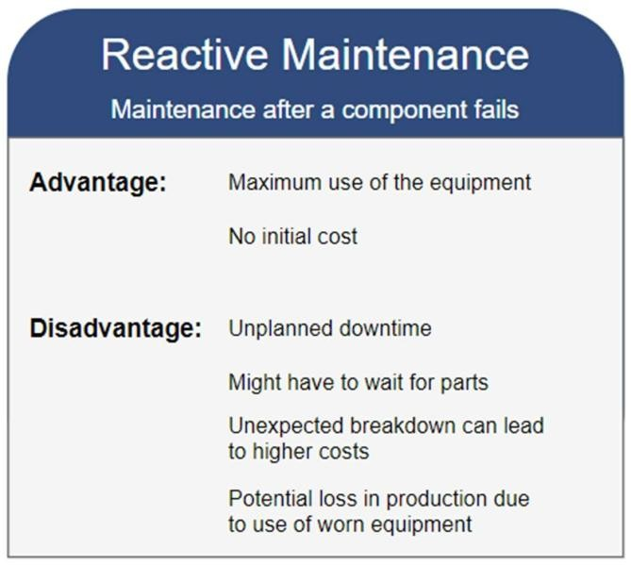

*Figure 1 Advantages and disadvantages of reactive maintenance*

##### 2.1.2 Preventive Maintenance

With preventive maintenance the maintenance is performed regularly based on previous experience and observations. This approach involves scheduled inspections, service, and repairs to detect and correct any issues before they become serious problems or break down. The goal is to minimize downtime, reduce repair costs, improve safety, and make sure everything runs effectively [3]. There are some drawbacks to preventive maintenance as well. The method is excellent for planning maintenance and avoiding long and costly downtimes to production, but components are often maintained before there is an actual need to do so. This takes time and money and might be an unnecessary cost for the company [3].

Figure 2 shows the advantages and disadvantages of preventive maintenance.

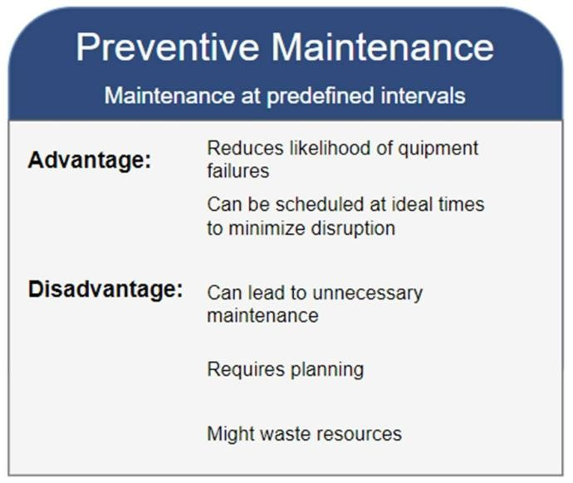

*Figure 2 Advantages and disadvantages of preventive maintenance*

##### 2.1.3 Predictive Maintenance

The objective of predictive maintenance is to optimize the timing of maintenance so that it’s done as necessary. Ideally, maintenance is neither too late, as often happens with reactive maintenance. And not too early, which could be the case with preventive maintenance [[3]. It’s not only possible to monitor for optimal maintenance times, but also to detect early signs of unusual wear or other problems [4]. Predictive maintenance is often implemented with systems like the Internet of Things (IoT), where sensors continuously monitor and analyze data to check the status of the equipment. The sensors gather data on relevant parameters, which could be things such as temperature, pressure, rotation speed, or sound. These sensors can automatically detect and alert when things deviate from what's normal and make it possible to take immediate actions. [4]High-quality data is crucial for PdM modeling. After gathering the raw data from the sensors, it will usually have to be pre-processed to handle noise or inconsistencies. It involves data cleaning, standardization, and the management of missing data. AI algorithms are used to analyze data to predict failures based on historical data. Decision-making modules can then use the insights and predictions from the AI 15 algorithms to recommend when maintenance should be performed [5].

Figure 3 shows the advantages and disadvantages of predictive maintenance.

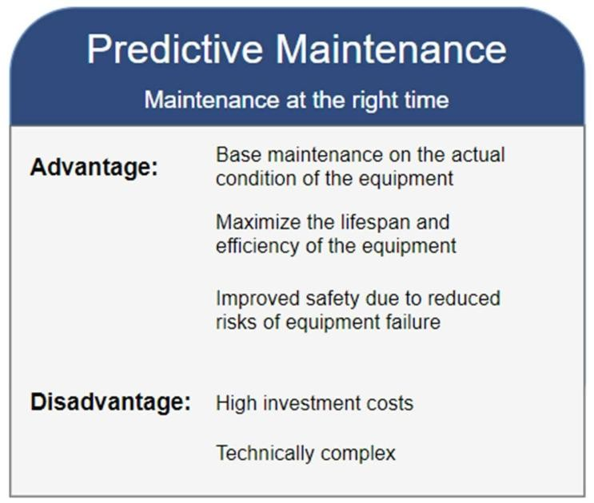

*Figure 3 Advantages and disadvantages of predictive maintenance*

## 2.2 Machine Learning

Machine Learning (ML) is a great tool for making predictions of future events based on collected historical data. After the data has been collected into datasets, the computer uses statistical methods to analyze data and identify patterns. The computer makes predictions from the data, assessing the accuracy against known outcomes. The predicted results are constantly refined by adjusting if there is an error. This ability to self-improve allows the algorithm to discover insights and improve its accuracy over time, without human assistance [6].

##### 2.2.1 Machine Learning Types

There are several types of machine learning; two of the main types are supervised learning and unsupervised learning. Supervised learning trains the algorithm with labelled data, where the correct output is known. The model learns by making predictions and adjusting based on the differences between its predictions and the actual 16 outcomes. This method is commonly used for tasks like classification and regression, where the goal is to predict the correct label or value. Unsupervised learning on the other hand trains a model using data that hasn’t been labelled. The algorithm tries to identify patterns in the data on its own. It’s useful for clustering and association tasks, where the goal is to group similar data points together or discover rules that describe large portions of the data [7], [8]. Supervised learning is further divided into classification- and regression problems. Classification can be used for discrete variables. The goal is to pair each input with the correct label. It deals with situations where there are only two possible classes for the inputs, while multi-class classification handles a greater number of classes. Regression learning handles outputs with continuous values [9].

## 2.3 Related Works

Several studies and projects have explored the application of predictive maintenance in various contexts. Below is a review of some relevant works:

### 1. Automation of Predictive Maintenance Using Internet of Things (IoT) Technology at University-Based O&M Project

Fernandez et al, explored the implementation of o IoT-based predictive maintenance to improve operational efficiency and reduce cost.

The approach involved monitoring asset health to detect failures early.

The automation was made possible using IoT technology. The study aimed to improve PM to CM ratio from 80:20 to 90:10

I. Methodology

* Data from 2019 CMMS at KSAU-HS O&M Project was analyzed.
* The current PM to CM ratio was 84:16.
* 72% of CM work orders were asset-related and could be addressed with IoT.
* A Fish Bone Diagram identified eight root causes for corrective maintenance.

II. Results

* Corrective Maintenance work orders reduced from 18,201 to 5,194 after implementing predictive maintenance.
* PM to CM ratio improved to 95:05, exceeding the target.
* Maintenance cost reduction ranged from 25% to 30%, translating to SAR 162,500,000 to SAR 195,000,000.
* Other benefits included a 70-75% reduction in breakdowns and a 20-25% increase in production.

III. Discussion

* The study achieved significant improvements in operational performance.
* Integration of AI could enhance predictive maintenance further.
* Real-time monitoring and analytics improved asset health management.

IV. Conclusion

* The research demonstrated the effectiveness of IoT in predictive maintenance.
* Key performance indicators improved significantly, with substantial cost savings and increased production.
* Future research should explore more advanced technologies and detailed implementation procedures.[10]

### 2. Hybrid Intelligent Predictive Maintenance Model for Multiclass Fault Classification

Buabeng et al proposed a hybrid predictive maintenance model that integrated Improved Complete Ensemble Empirical Mode Decomposition with Adaptive Noise (ICEEMDAN), Principal Component Analysis (PCA), and Least Squares Support Vector Machine (LSSVM) optimized by Coupled Simulated Annealing and Nelder-Mead Simplex algorithms. The model aimed to enhance fault classification accuracy in complex industrial systems characterized by high-dimensional, nonlinear, and uncertain data.

* The proposed model was named ICEEMDAN-PCA-LSSVM.
* It effectively handled high levels of uncertainty in industrial data.
* The model outperformed established classifiers like LDA, SVM, and ANN in accuracy and error rates.
* It reduced redundancies and dimensions of features, improving classification efficiency.

Machine Learning in Predictive Maintenance

Machine Learning (ML) algorithms are widely used in predictive maintenance due to their ability to process multivariate and high-dimensional datasets. However, many ML algorithms are task-specific and struggle with nonlinear and nonstationary data.

* ML algorithms can extract hidden patterns and classify data effectively.
* A significant number of ML algorithms are not generalizable across different tasks.
* Hybrid frameworks combining multiple ML algorithms are gaining attention for improved performance.

Proposed Hybrid Framework Details

The study introduced a hybrid framework that combined ICEEMDAN, PCA, and LSSVM, optimized using CSA and NMS algorithms. This approach aimed to improve fault classification in hydraulic systems.

* ICEEMDAN decomposes signals into Intrinsic Mode Functions (IMFs) to reduce noise.
* PCA extracts relevant features, reducing dimensionality and redundancy.
* LSSVM was chosen for its computational efficiency and improved classification performance.
* The hybrid optimization approach enhanced convergence speed and accuracy.

Data Pre-processing Techniques for Fault Classification

The study presented a hybrid approach utilizing ICEEMDAN for denoising and feature extraction, followed by PCA for dimensionality reduction, and LSSVM for classification. This method effectively addressed the challenges posed by nonlinear, nonstationary signals in hydraulic systems.

* ICEEMDAN was employed to decompose signals into Intrinsic Mode Functions (IMFs) while reducing noise.
* A stringent threshold was used to select relevant IMFs for signal reconstruction, enhancing fault feature extraction.
* The process resulted in a significant reduction of features from 43,680 to 1,806 after statistical feature extraction.
* PCA was applied to the denoised features, retaining 82 principal components that explained

Classification Methodology and Optimization Techniques

The classification was performed using LSSVM optimized by CSA-NMS, which enhanced computational efficiency and accuracy. The study compared the proposed method with established classifiers to demonstrate its effectiveness.

* LSSVM was chosen for its computational efficiency and ability to handle multiclass classification.
* CSA was used to determine optimal parameters, while NMS fine-tunes these parameters for better classification performance.
* The proposed ICEEMDAN-PCA-LSSVM model achieves an average test accuracy of over 99.40% across all monitored conditions.

Performance Evaluation Metrics for Classification

A comprehensive evaluation of the classification models was conducted using multiple metrics to ensure reliability and robustness. This included accuracy, precision, recall, and more.

* Eight evaluation metrics were used: accuracy, error rate, precision, recall, specificity, F score, Matthews correlation coefficient, and geometric mean.
* The proposed model achieves an accuracy of 99.44% for the accumulator condition, significantly higher than previous methods (LDA: 54.0%, ANN: 50.4%).
* The model also demonstrated high sensitivity (99.41%) and specificity (99.80%).

Comparative Analysis of Classification Results

The study compared the performance of the proposed ICEEMDAN-PCA-LSSVM model with other classifiers, highlighting its superiority in various fault conditions.

* The proposed model outperformed LDA, SVM, and ANN in classifying hydraulic system conditions.
* For the cooler condition, the model achieved 99.83% accuracy, while for internal pump leakage, it reached 100% accuracy.
* The results indicated that the proposed hybrid model is versatile and effective across different monitored conditions.

Conclusion and Future Work Directions

The study concluded that the proposed hybrid approach significantly enhances fault classification accuracy and reliability. Future research should focus on improving the model's adaptability to signals with mutations and exploring deep learning techniques.

* The ICEEMDAN-PCA-LSSVM model was effective for various fault conditions, improving classification accuracy and reducing feature redundancy.
* Future work should explore advanced filtering techniques and deep learning for better feature extraction and classification performance. [11]

### 3. Design and Control of High Thermal Mass Radiant Systems By Carlos Duarte Roa UC Berkeley HVAC Systems (2020)

Duarte Roa (2020) presented a comprehensive study on high thermal mass radiant (HTMR) systems as a sustainable alternative to conventional all-air HVAC systems in buildings. The work identifies major inefficiencies in current HVAC design standards, especially those related to cooling load definitions and system sizing, which often lead to oversized and energy-intensive cooling plants. By proposing a new design methodology tailored for HTMR systems, the study emphasizes the potential of leveraging the systems' thermal inertia for demand shifting and energy savings.

The research included simulations across varied U.S. climate zones and field implementations in two Californian buildings. These showed significant improvements in energy consumption and thermal comfort through adaptive control strategies. For example, the new HTMR control strategy reduced over-temperature hours from 9.1% to 1.6% of occupied time and cut daily energy use by up to 93% compared to baseline systems.

This work directly aligned with predictive maintenance efforts in campus environments like KNUST, especially in applications involving HVAC systems. Its insights into control optimization, energy modeling, and demand management are critical for designing systems that are not only proactive in maintenance but also efficient and sustainable.

**Limitations of the Study:**

1. High Dependency on Accurate Building Models and Simulations

The success of HTMR design and control strategies relied heavily on accurate energy modeling and thermal simulations. Real-world implementation may differ due to unaccounted-for variables like occupant behavior, weather unpredictability, or construction inaccuracies.

1. Complexity in Control System Design

While the study proposed an advanced adaptive control system, its complexity may be a barrier for adoption in low-resource settings or institutions without skilled facility management teams.

1. Limited Generalizability Across Building Types

The findings were validated primarily through case studies in California with specific climate and infrastructure conditions. Applying the same strategies in tropical or highly humid climates (e.g., Ghana) may require additional adjustments or revalidation.

1. Required Long-Term Data and Infrastructure Investment

The effectiveness of HTMR systems increased over time and depended on well-instrumented buildings (e.g., slab temperature sensors, water flow meters). This could pose a challenge in environments where such infrastructure is lacking.[12]

### Makerere University's PdM Pilot (2021) – Nalubega & Kavishe

In 2021, researchers Nalubega and Kavishe at Makerere University initiated a pilot project focusing on predictive maintenance within the context of Uganda's industrial sector. The study aimed to assess the feasibility and effectiveness of implementing PdM strategies in local manufacturing environments, which often face challenges such as limited resources and infrastructure. By integrating sensor technologies and data analytics, the project sought to monitor equipment health and predict failures before they occurred. The pilot demonstrated that even in resource-constrained settings, adopting PdM approaches could lead to significant improvements in equipment uptime and maintenance efficiency. The findings underscore the potential for PdM to enhance operational reliability in similar contexts across Sub-Saharan Africa.

**Limitations of the Study:**

* Lower Predictive Accuracy: The pilot relied on simpler models such as logistic regression, which, while easier to implement, offer lower accuracy compared to more advanced machine learning models.
* Resource Constraints: The setting involved low-resource environments, which limited the availability of high-quality sensor hardware, computing infrastructure, and consistent power supply.
* Scalability Issues: The solution worked well in a pilot environment, but scaling to larger industrial setups or diverse types of equipment may require significant adaptation and investment.
* Limited Historical Data: Because of the novelty of such systems in the region, limited historical maintenance data reduced model training effectiveness.[13]

### 5. NTU Singapore (2022) Acoustic-Based Early Fault Detection in Classroom Projectors Using Deep Learning, Tan et al.

Tan et al. (2022) from Nanyang Technological University developed a predictive maintenance system for aircraft engines utilizing Azure cloud services. The project employed a portable microcontroller (B-L475E-IOT01A) attached to aircraft engines to collect realtime health parameters, which were then transmitted to Azure IoT Central for analysis. This approach enabled continuous monitoring without disrupting operational availability. The system successfully predicted maintenance needs, allowing for timely interventions and reducing unnecessary downtime. The study highlights the efficacy of integrating IoT devices with cloud-based analytics in implementing PdM solutions within the aerospace industry Limitations:

* Sensitivity to Environmental Noise: The predictive system for detecting faults in classroom projectors via acoustic data was highly sensitive to ambient noise, which could lead to false positives or missed detections.
* Hardware Dependency: The approach depended on a specific microcontroller and sensor suite, which may limit adaptability to other environments or devices.
* Cloud Dependency: The system’s reliance on Azure IoT Central means continuous internet connectivity is crucial. This could be a limitation in environments with unstable networks or where data privacy concerns limit cloud usage.
* Complex Setup for Small-Scale Applications: For smaller institutions or non-technical users, implementation and maintenance of the system may require technical expertise that isn't readily available.[14]

## 2.4 Challenges in Predictive Maintenance

Predictive maintenance (PdM) aims to reduce costs and enhance competitive strength by utilizing sensor data and analytics.

* Noisy or erroneous sensor data is prevalent in real-world environments, complicating data analysis.
* High volumes of data must be collected, transmitted, and processed promptly to be effective.
* Current PdM approaches are often specific to individual parts or equipment rather than being comprehensive.
* Anomaly detection helps eliminate noise and identify relevant events for improved prognostics.
* Prognostics methods focus on forecasting the condition of industrial equipment.

###### **Anomaly Detection in Predictive Maintenance**

Anomaly detection is crucial for identifying deviations in data that may indicate equipment malfunctions or sensor errors. Effective anomaly detection can enhance prognostics models by filtering out noise and providing valuable insights from sensor data.

* Anomalies can be caused by sensor malfunctions, equipment failures, or external disturbances.
* Types of anomalies include point anomalies, collective anomalies, and contextual anomalies.
* Centralized approaches process data on a single server, while distributed solutions utilize multiple components for real-time detection.
* Recent research employs statistical and machine learning methods, with a focus on exploiting correlations between multiple sensors.
* Techniques such as fuzzy clustering, DBSCAN, and Principal Component Analysis (PCA) are commonly used for anomaly detection.
* The challenge lies in distinguishing between noise and relevant anomalies, with recent methods achieving up to 96% accuracy in noise detection.

###### **Prognostics Methods in Predictive Maintenance**

Prognostics involves forecasting the remaining useful life (RUL) of machinery based on degradation models, which can significantly improve maintenance scheduling. Various approaches, including knowledge-based, physics-based, and data-driven models, are utilized to enhance predictive maintenance strategies.

* Prognostics is essential for scheduling maintenance actions based on predicted equipment states.
* Data-driven models leverage statistical and machine learning techniques to analyze sensor data for RUL estimation.
* Knowledge-based approaches rely on expert insights, while physics-based models use mathematical representations of physical processes.
* The integration of anomaly detection with prognostics can improve model accuracy and reliability.
* Challenges include the need for large labelled datasets and the specificity of models to equipment types. [15]

Based on the challenges highlighted above, the challenges that will be directly encountered when implementing a predictive maintenance system in the KNUST campus include:

1. Data Quality: The accuracy of predictive maintenance systems depends on the quality of the data collected. Poor data quality can lead to inaccurate predictions and false alarms.
2. Integration with Existing Systems: Implementing predictive maintenance often requires integrating new technologies with existing systems, which can be complex and costly.
3. Cost of Implementation: The initial cost of implementing a predictive maintenance system, including the installation of sensors and the development of algorithms, can be high.
4. Skill Requirements: Predictive maintenance systems require skilled personnel to develop and maintain the algorithms, analyse data, and interpret results.

## 2.5 Conclusion

The literature review highlights the potential of predictive maintenance to transform facility management by reducing downtime, lowering costs, and extending equipment lifespan. However, challenges such as data quality, system integration, and implementation costs must be addressed to realize these benefits. This project aims to build on existing research by developing a predictive maintenance system tailored to the needs of KNUST, with a focus on data collection, analysis, and user-friendly interface.

# Chapter 3: Methodology

## 3.1 Introduction

This chapter outlines the systematic approach adopted in this project. The software process model is discussed along with the processes undertaken to develop this project.

## 3.2 Software Process Model

Software process models are frameworks or approaches that defines how software development activities are structured and carried out.

3.2.1 Waterfall Model

The Waterfall model is a linear, sequential approach to software development where each phase must be completed before the next begins. It emphasizes structured documentation and clear milestones, making it ideal for projects with well-defined requirements where the scope is defined early. While having the limitations of inflexibility to changes and being slower compared to some alternative process models, its nature suits the needs of this project.

*Table 1 Overview of the development cycle of the Waterfall Model*

|  |  |  |
| --- | --- | --- |
| **Phase** | **Activities** | **Outcomes** |
| **1. Requirements** | * Gather stakeholder needs (maintenance staff, faculty). * Define system scope (projectors, ACs, podiums). | Software Requirements  Specification (SRS) document. |
| **2. System Design** | * Database schema (Equipment, Maintenance Log). * UI wireframes (Figma). | ER diagrams, architectural blueprints. |
| **3. Implementation** | - Develop CRUD modules (Laravel). - Integrate rule-based alerts. | Functional system with equipment tracking and alerts. |
| **4. Testing** | * Unit tests (PHPUnit). * User acceptance testing (3 KNUST staff). | Test reports, bug fixes. |
| **5. Deployment** | * Deploy to KNUST’s server (Laravel Forge). * Train end-users. | Live system at maintenance.knust.edu.gh. |
| **6. Maintenance** | * Monitor performance. * Address post-deployment issues. | Updated documentation, minor patches. |

## 3.2 Justification for Waterfall

1. Clear milestones: Structured progression through distinct phases ensures phased deliverables.
2. Documentation focus: critical for user training and future scalability.

# 3.3 Tools & Technologies

1. Backend: Laravel 10, MySQL.
2. Frontend: Blade, Tailwind CSS.
3. Testing: PHPUnit, BrowserStack.

# References

1. Ingela Holmkvist, “Implementing Predictive Maintenance For Small and Medium-Sized Enterprises ”.
2. A. Buabeng, A. Simons, N. K. Frempong, and Y. Y. Ziggah, “Predictive Maintenance Model Based on Multisensor Data Fusion of Hybrid Fuzzy Rough Set Theory Feature Selection and Stacked Ensemble for Fault Classification,” *Math Probl Eng*, vol. 2022, pp. 1–24, Jun. 2022, doi:

10.1155/2022/4372567.

1. “What is Reactive Maintenance? | IBM.” Accessed: May 01, 2025. [Online]. Available: https://www.ibm.com/think/topics/reactive-maintenance
2. M. Pech, J. Vrchota, and J. Bednář, “Predictive Maintenance and Intelligent Sensors in Smart Factory: Review,” *Sensors*, vol. 21, no. 4, p. 1470, Feb. 2021, doi: 10.3390/s21041470.
3. A. Ucar, M. Karakose, and N. Kırımça, “Artificial Intelligence for Predictive Maintenance Applications: Key Components, Trustworthiness, and Future Trends,” *Applied Sciences*, vol. 14, no. 2, p. 898, Jan. 2024, doi: 10.3390/app14020898.
4. “What Is Machine Learning (ML)? - I School Online.” Accessed: May 01, 2025. [Online].

Available: https://ischoolonline.berkeley.edu/blog/what-is-machine-learning/

1. “Supervised vs Unsupervised Learning Explained - Take Control of ML and AI Complexity.” Accessed: May 01, 2025. [Online]. Available: https://www.seldon.io/supervised-vs-unsupervisedlearning-explained-2/
2. “Supervised and Unsupervised Learning (an Intuitive Approach) | by Metehan Kozan | Medium.” Accessed: May 01, 2025. [Online]. Available: https://medium.com/@metehankozan/supervisedand-unsupervised-learning-an-intuitive-approach-cd8f8f64b644
3. “Classification in Machine Learning: A Guide for Beginners | DataCamp.” Accessed: May 01,

2025. [Online]. Available: https://www.datacamp.com/blog/classification-machine-learning

1. J. R. Fernandez, Y. T. Prasetyo, S. F. Persada, and A. A. N. Perwira Redi, “Automation of predictive maintenance using internet of things (Iot) technology at university-based o&m project,” *International Journal of Information and Education Technology*, vol. 11, no. 7, 2021, doi:

10.18178/ijiet.2021.11.7.1531.

1. A. Buabeng, A. Simons, N. K. Frimpong, and Y. Y. Ziggah, “Hybrid Intelligent Predictive Maintenance Model for Multiclass Fault Classification,” Jul. 06, 2021. doi: 10.21203/rs.3.rs600110/v1.
2. C. Duarte, “UC Berkeley HVAC Systems Title Design and control of high thermal mass radiant systems.” [Online]. Available: https://escholarship.org/uc/item/82t6n3xr
3. N. Es-sakali, M. Cherkaoui, M. O. Mghazli, and Z. Naimi, “Review of predictive maintenance algorithms applied to HVAC systems,” *Energy Reports*, vol. 8, pp. 1003–1012, Nov. 2022, doi:

10.1016/J.EGYR.2022.07.130.

1. R. Tian, S. Gomez-Rosero, and M. A. M. Capretz, “Health Prognostics Classification with Autoencoders for Predictive Maintenance of HVAC Systems,” *Energies (Basel)*, vol. 16, no. 20, Oct. 2023, doi: 10.3390/EN16207094.
2. P. Nunes, J. Santos, and E. Rocha, “Challenges in predictive maintenance – A review,” 2023. doi:

10.1016/j.cirpj.2022.11.004.